Image | 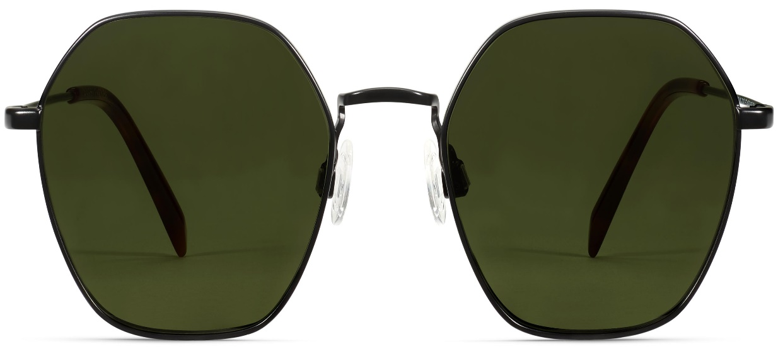
Brand | TOM FORD
Model Name | Keiko
Price | RS 1459
PRODUCT DETAILS

